

Dental laboratory

Дата --------------------- №------------

Стоматолог ------------------------------------------------------------------------------------
Вид работа ------------------------------------------------------------------------------------
Име на пациента -----------------------------------------------------------------------------

Проби 1---------------------------------------------------
2---------------------------------------------------
3---------------------------------------------------

Цвят………………………… статус
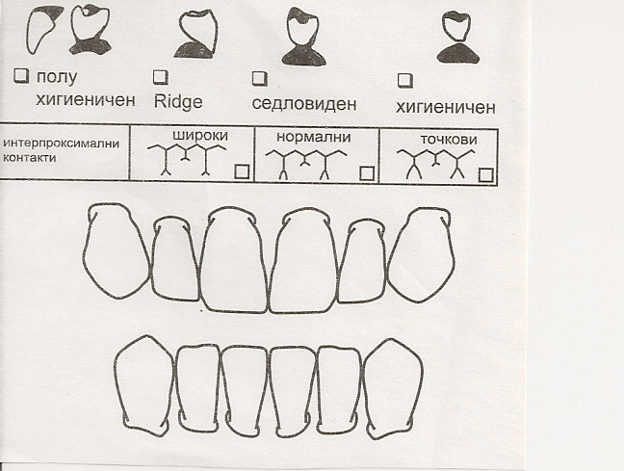 |

Завършено на (дат./час)……………………………………………………………………………………
Важно!!!................................................................................................................................................................................................................................................................................................................................................................................................................................................................................................................................................................................

София 1574
кв. „Редута“
ул. „Боян Магестник“10
моб.:0887 838 446
0878 838 446
e-mail: s.j.v@abv.bg

